**EXPERIMENT NO - 03**

**RELATIONAL MODEL FOR A COLLEGE DATABASE.**

**Aim:** Draw a relational model for a college database.

**OBJECTIVES**: Relational Model represents how data is stored in Relational Databases. A relational database stores data in the form of relations (tables). Consider a relation STUDENT with attributes ROLL_NO, NAME, ADDRESS, PHONE and AGE.

**IMPORTANT TERMINOLOGIES OF RELATIONAL MODEL:**

**Attribute**: Attributes are the properties that define a relation.

**Relation Schema**: A relation schema represents name of the relation with its attributes.

**Tuple**: Each row in the relation is known as tuple.

**Relation Instance:** The set of tuples of a relation at a particular instance of time is called as relation instance

**Degree:** The number of attributes in the relation is known as degree of the relation.

**Cardinality**: The number of tuples in a relation is known as cardinality.

**Column**: Column represents the set of values for a particular attribute.

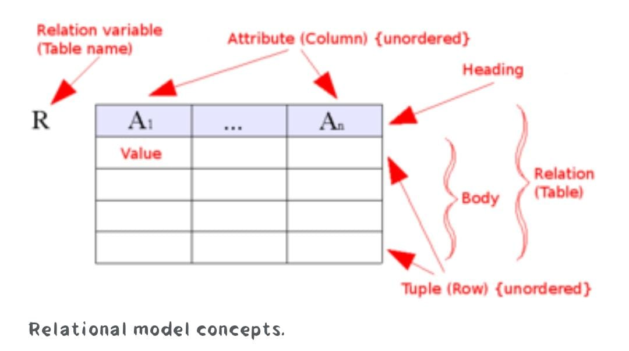

**\*\*\*\*\*\*\* RELATIONAL MODEL OF COLLEGE DATABASE \*\*\*\*\*\*\***

